|  |
| --- |
| BUSINESS ANALYTICS  SYSTEM SPECIFICATION FOR BRITISH GAS CORPORATION |

|  |
| --- |
| British Gas Logo, symbol, meaning, history, PNG, brand |

|  |  |
| --- | --- |
| Project Specification Prepared by Mohamed Basharul Khan  Word Count: 2214 approximately excluding references and tables |  |



Contents

PROJECT DESCRIPTION 3

Problem Overview and System Proposal 3

Company Vision and Goal 3

Requirement Gathering 4

Company Strategic Business Scorecard 4

Essential Features Of Dashboard 4

Stakeholder List 5

Work Breakdown Structure 5

Budget Plan 7

CEO DASHBOARD DESIGN 8

Chief Executive Officer Dashboard 8

Metric Aggregation Of Ceo Dashboards 9

CSD DASHBOARD DESIGN 16

Chief Service Director Dashboard 16

Metric Aggregation Of Csd Dashboards 17

CMO DASHBOARD DESIGN 23

Chief Marketing Officer Dashboard 23

Metric Aggregation Of Cmo Dashboards 24

OVERALL ANALYSIS DIMENSIONS 30

CONCLUSION 31

REFERENCES 32

|  |
| --- |
| PROJECT DESCRIPTION |

|  |
| --- |
| Problem Overview and System Proposal British Gas is a large utility company in the United Kingdom with operations across the country. One of their main concerns is customer churn, the percentage of customers who cancel their service within 12 months. In recent years, British Gas has seen a significant increase in customer churn rate. For example, British Gas lost 2% of its customers due to the pandemic and greater competition and posted record-low profits (Richard Simmonds (2021)). It represents a significant increase over a short period and needs investigation to determine the cause of this problem and possible mitigation strategies.  The reasons for higher customer churn rates are:   * Customer dissatisfaction because of poor level of customer service. * Software glitches in smart energy meters. * The estimation of bills was wrong sometimes. * The rise in energy costs.   To track all these problems, our business intelligence team has come up with a solution of developing intuitive dashboards for the senior executives in British gas to monitor and act accordingly. It will represent the status of the company’s relationship with customers so that senior executives customize their plan and get the people into action, which will eventually gain customer trust. Company Vision and Goal British gas organisation's strategists come up with goals and visions to improve the company's position financially. The goals are   1. Provide 20% discounts on their monthly bills to make the customer feel comfortable when making their bill payment. 2. Strengthen the customer service teams to give British gas customers the best quality service. 3. Deploy expert technical people to solve issues in software and hardware-related issues of customers. 4. Maintain customer trust and retention through social media marketing by providing them with offers and vouchers and showing them the benefits of British gas customers.   Centrica (2023), the parent company of British gas, stated, “Our organisation provides energy-related services and products. Helping our consumers live sustainably and inexpensively is the motivation behind our strategy. We will adapt by concentrating personnel and technological resources on assisting organisations and households in making more sustainable and energy-efficient energy use." |

## Requirement Gathering:

After initial discussion and clarification sessions with the stakeholders, our team got a clear and complete idea for the subsequent proceedings. For example, the Dashboard to be presented to the senior executives should be customer-centric, and the metric should define and match the company's goals and strategy.

Third-party company Ipsos provides the British Gas data to us, and we need to import the data into our server. Then we will start our business analysis process.

The Dashboard should explain the current situation and customers' issues and give powerful insights to the senior executive. As a result, they will take informed decisions to improve the company. In addition, the Dashboard can be shared with other people in the organization internally through email or internal communication software.

**Company Strategic Business Scorecard:**

Figure 1. Business Scorecard of British Gas

Essential features of Dashboard:

Dashboards strongly emphasise high-level performance indicators, such as projections, to illuminate the way forward. While simple performance evaluators (such as good and bad) and contextual information, such as comparisons to targets and brief histories, can help to clarify the meaning of these measures, having too much contextual information or too many subtle gradations can detract from the primary and immediate goals of the strategic decision maker (Few, S. (2006)). Based on that, the dashboards developed in favour of senior executives, such as:

1. The KPI established must match the overall organisation’s tactical requirements and strategic objectives.
2. The Dashboard is capable of extracting real-time data from multiple organisations.
3. The user can drill down on highlighted information to retrieve, review, analyse and share information with good detail.
4. The colours and theme of a dashboard can change according to the user's needs.
5. The User Interface is accessible to make users navigate easily to their required destination.

Stakeholder List:

|  |  |
| --- | --- |
| Designation | Name |
| Chief Executive Officer | Chris O Shea |
| Customer Service Director | Martin O Neill |
| Chief Marketing Officer | Rob Strawson |

Work Breakdown Structure:

This project comprises work packages that need around three months to research, analyse, develop and support End to End. These work activities developed through close collaboration with project team members and stakeholders. This work breakdown structure will help in resource planning, task completion and ensuring deliverables meet project requirements.

The methodology used is the agile process. This process promotes sustainable development, enhances agility, and welcomes changes even late in development.

First, we import the data from the Ipsos organization then we will restructure the data and clean the data for better quality. Then our Business Intelligence developers develop dashboards based on the final design approved by British gas senior executives.

Automated Testing should be done at each final development of the dashboard and fix issues and deliver to senior executives for the final approval to launch live. We will support the project for a certain period to fix issues and improve the dashboard based on user feedback.

The Project plan and timeline were explained visually in Figure 2 and Figure 3.

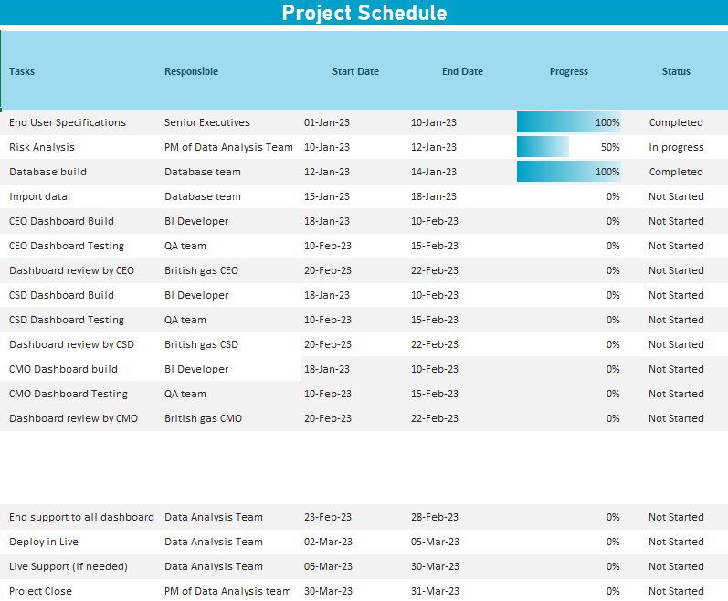

Figure 2. Project Schedule for British Gas

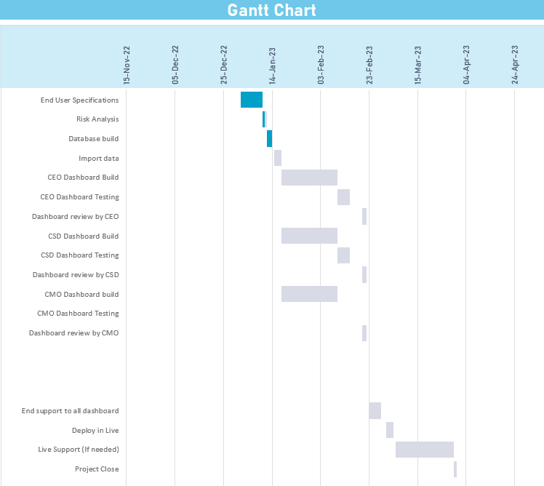

Figure 3. Gantt chart

Budget Plan:

We have estimated the budget based on Labour costs, Software and Testing tools and included final support works. Additional charges are applicable in case of new specifications requested by senior executives.

|  |  |
| --- | --- |
| Labour Costs | 40000£ |
| Software and Testing Tools Costs | 10000£ |
| Final Support | 10000£ |
| Estimated Total Project Costs | 60000£ |

## Chief Executive Officer Dashboard:

|  |
| --- |
| CEO DASHBOARD DESIGN |

The CEO of British gas requested reports based on Customers and revenue mainly focused. The Dashboard includes churn rates of customers and revenue, the Recurring revenue of the organisation and the Promotion score of the Company.

From these specifications, CEO can be able to:

1. Track and measure the Company's goals and targets based on the Company's strategy.
2. Monitor the performances of Customers and Internal departments
3. Get Valuable insights and trends from historical data.
4. Identify the Strength and Weaknesses of departments.
5. Share dashboards and graphs in the organisation internally as PDF or JPG document.

Figure 4. Wireframe diagram of CEO Dashboard

**METRIC AGGREGATION OF CEO DASHBOARD**

**Customer Churn:**

The *Customer Churn* explains the percentage of customers that stopped using British gas energy supplying service. It helps the CEO to identify why they have stopped and help him to make an informed decision.

Figure 5. Customer churn chart example

|  |  |  |
| --- | --- | --- |
| **Customer Churn Formula** | **Range** | **Data Sources** |
| (Lost Customers at British gas / Total British gas Customers at the start of the period) * 100 | (1-100) %  • Lower rates (For Eg. 1.43%, 0.67%) - This refers to that customers are loyal.  • Higher rates (For Eg. 20%,50.4%) - This refers to that customers who are not loyal and are shifting to another energy supplier. | Customer Details |

**Revenue Churn:**

Revenue churn is a metric used to quantify the revenue lost due to customers downgrading, cancelling services, or not paying their bills, resulting in a monthly recursive revenue loss. It helps the CEO get to know the organisation's revenue loss.

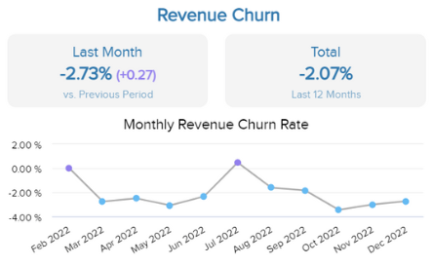

Figure 6. Revenue churn chart example

|  |  |  |
| --- | --- | --- |
| **Revenue Churn**  **Formula** | **Range** | **Data Sources** |
| Gross British gas revenue churn =  Churned British gas MRR /British gas MRR at the beginning of the period. | (-100 - 100) %  • If the churn rate is negative, it represents a positive development.  • If the churn rate is positive, it represents a negative development. | Revenue |

**Customer acquisition cost:**

*Customer acquisition costs* explain the costs incurred in convincing a prospect to buy the service. This metric helps the CEO know the investment made to get new customers.

Figure 7. Customer acquisition cost chart example

|  |  |  |
| --- | --- | --- |
| **Customer acquisition cost formula** | **Range** | **Data Source** |
| (Cost of British gas sales + Cost of British gas marketing) / Number of new customers acquired. | Minimum (0) - Maximum (any) -> In pounds | • Sales  • Marketing  • Customer details |

**Monthly Recursive Revenue (MRR):**

The *Monthly Recursive Revenue* metric will explain the revenue made each month. The CEO keeps a close eye on the MRR and monitors whether it indicates that the business is developing healthily. The CEO can drill down to see the detailed graphical interface of MRR, to get more insights.

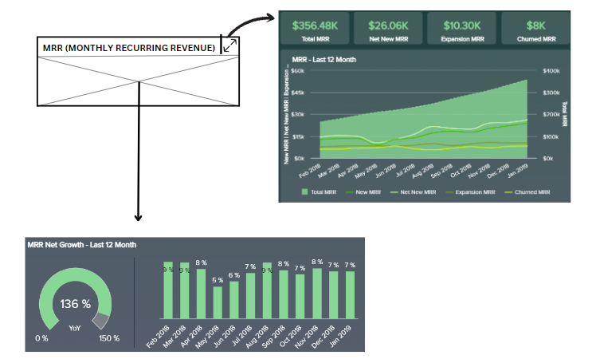

Figure 8. Monthly Recurring Revenue chart example

|  |  |  |
| --- | --- | --- |
| **MRR formulas** | **Range** | **Data Source** |
| • **Net MRR** = Existing MRR + New Customer Revenue +Customer Reactivation MRR+ Expansion MRR - Chruned MRR.  • **Gross MRR** = The Number of Active customers * Average revenue per customer  • **Churned MRR** = (Number of Non-Active Customers/ Cancelled Contracts / MRR) *100  • **Expansion MRR** = Monthly revenue - Revenue from new customers. | Minimum (0) - Maximum (any) -> In pounds | • Sales  • Revenue  • Customer details |

**Customer Lifetime Value:**

The *Customer Lifetime Value* metric will show how much revenue the organisation’s repeat or loyal customers drive to the British Gas energy supplier. In addition, it will help the CEO to envision and plan for the future of the British gas corporation based on customer trust.

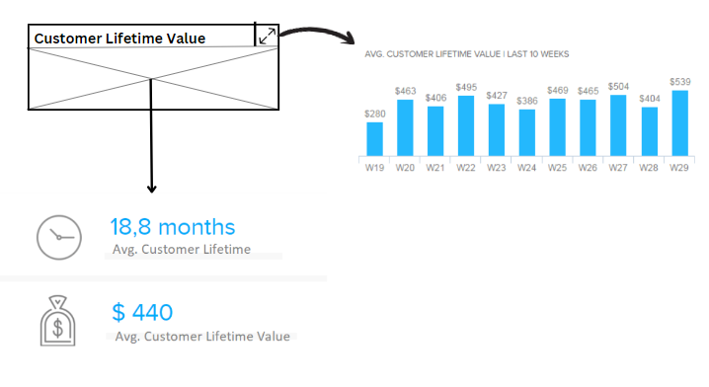

Figure 9. Customer Lifetime Value chart example

|  |  |  |
| --- | --- | --- |
| **Customer Lifetime Value Formula** | **Range** | **Data Source** |
| Average annual revenue * Average lifespan of a customer | Minimum (0) - Maximum (any) -> In pounds | • Revenue  • Customer Details |

**Customer Loyalty Rate:**

The *Customer Loyalty rate* metric will show customers' repeat bill payment ratio. In addition, it will help the CEO learn about the customer's relationship with British gas.

Figure 10. Customer Loyalty Rate chart example

|  |  |  |
| --- | --- | --- |
| **Customer Loyalty Rate Formula** | **Range** | **Data Sources** |
| Total Number of customers who made bill payments regularly / Total Number of Customers active for the observed period. | (1-100) %   * High Percentage - Good Customer Loyalty rate. * Low Percentage - Poor Customer Loyalty rate | * Customer Details * Revenue |

**Net Promoter Score (NPS):**

The *Net Promoter Score* metric will show how customers perceive British gas service and its businesses. In addition, it will make the CEO aware of the British gas service's favourability to customers.

Figure 11. Net Promoter Score chart example

|  |  |  |
| --- | --- | --- |
| **NPS Formula** | **Range** | **Data Sources** |
| Percentage of Promoters - Percentages of Detractors | (0-10)   * Promoters (9-10) * Passives (7-8) * Detractors (0-6) | * Survey Responses. * Customer Feedback Data. |

|  |
| --- |
| CSD DASHBOARD DESIGN |

Customer Service Director Dashboard:

The CSD of British gas requested reports based on Customer service and Employee Performance mainly focused. In addition, the Dashboard includes average reply and resolution time to customers, Customer satisfaction and retention score to get to know the Company's relationship with British gas customers.

From these specifications, CSD can be able to:

1. Track and measure the customer experience with the organization.
2. Monitor the performances of Employee and their rate of response.
3. Get Valuable insights and trends from historical data.
4. Identify the Strength and Weaknesses of Customer service teams.
5. Share dashboards and graphs in the organization internally as PDF or JPG documents.

Figure 12. Wireframe diagram of CSD Dashboard

**METRIC AGGREGATION OF CSD DASHBOARDS**

**Ticket Volume:**

The *Ticket volume* metric will show the number of customer complaint tickets in the support queue for a certain period. It helps CSD to analyse the general pulse of the health of customer service teams, and he can drill down and see the detailed illustration of the Customer Complaint tickets.

Figure 13. Ticket Volume chart example

|  |  |  |
| --- | --- | --- |
| **Ticket Volume Formula** | **Range** | **Data Source** |
| Sum of all customer complaint tickets | Minimum (0) - Maximum (any number) | * Customer Communication data * Customer Complaint data |

**Customer Retention Rate:**

The *Customer Retention* percentage rate will show how many customers the organisation can retain over time. In addition, it helps CSD evaluate the organisation's strength and exemplary service to customers if the percentage is high.

Figure 14. Customer Retention Rate chart example

|  |  |  |
| --- | --- | --- |
| **Customer Retention Rate Formula** | **Range** | **Data Sources** |
| ((E-N)/S) * 100  E - Number of total customers at the end of the period  N - Number of new customers added within the period  S - Number of existing customers at the start of the period | (0 to 100) % | Customer Data |

**Customer Satisfaction Score (CSAT):**

The *Customer Satisfaction Score* metric will show the level of satisfaction of customer feels after a conversion, conversation or interaction with the British gas business. In addition, it helps CSD to know customer happiness because of their business.

Figure 15. Customer Satisfaction Score chart example

|  |  |  |
| --- | --- | --- |
| **CSAT Formula** | **Range** | **Data Sources** |
| (Total number of satisfied answers (rating of 4 or 5) / Total number of answers) * 100 | (0 - 100) % (or)  (1 - 5) Rating  5 - Very Satisfied  4 - Satisfied  3 - Neutral  2 - Unsatisfied  1 - Very Unsatisfied | Customer Feedback Survey response |

**Average Reply Time:**

The *Average Reply Time* metric shows the time taken for a customer service agent to reply to a customer complaint. In addition, it helps CSD monitor the customer service employees' performance in responding to customers, and, he can also drill down the Dashboard to retrieve performance reports each day.

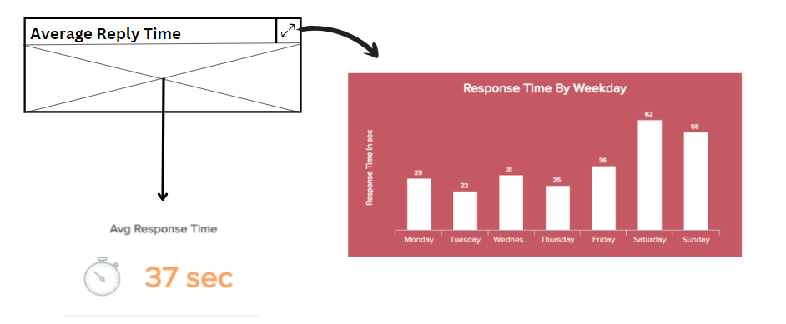

Figure 16. Average Reply Time chart example

|  |  |  |
| --- | --- | --- |
| **Average Reply Time Formula** | **Range** | **Data Sources** |
| Total time spent by a customer waiting for a reply / Number of customer messages needing a reply | Minimum (1 second) - Maximum (any hours) | Communication Record Data |

**Average Resolution Time:**

The *Average Resolution Time* metric will show the amount of time it takes for the Customer service agent to resolve a customer ticket from the time it opened. In addition, it helps CSD get to know the resolved and unresolved cases and plan accordingly.

Figure 17. Average Reply Time chart example

|  |  |  |
| --- | --- | --- |
| ****Average Resolution Time Formula**** | ****Range**** | ****Data Sources**** |
| There Average Resolution Time is classified into four types,   * First Contact Resolution Time = Total duration of resolved conversation at first contact / Number of total customer conversation * Second Contact Resolution Time = Total duration of resolved conversation at second contact / Number of total customer conversation * (Third or More) Contact Resolution Time = Total duration of resolved conversation at (Third or More) contact / Number of total customer conversation | Minimum (1 second) - Maximum (any hours) | Communication Record Data |

**Employee Rating:**

The *Employee Rating* metric will show the employees' ability and quality of work. In addition, the CSD can track employee performance and compare the outcome with company strategy and expectations.

Figure 18. Employee Rating chart example

|  |  |
| --- | --- |
| Rating | Data Sources |
| (1 - 5) Rating  5 - Outstanding  4 - Exceeds Expectations  3 - Meets Expectations  2 - Needs Improvement  1 – Unacceptable | Customer Feedback Survey response |

|  |
| --- |
| CMO DASHBOARD DESIGN |

Customer Marketing Officer Dashboard:

The CMO of British gas requested reports based on Marketing and Revenue mainly focused. In addition, the Dashboard includes the Customer Conversion Rate and Cost per Acquisition of customers and a few significant KPIs.

From these specifications, CMO can be able to:

1. Track and measure the marketing performance data across all your different marketing channels and campaigns.
2. Monitor the Total costs vs Planned costs for Marketing.
3. Get Valuable insights and trends from historical data.
4. Identify the Strength and Weaknesses of Customer conversion criteria.
5. Share dashboards and graphs in the organization internally as PDF or JPG documents.

Figure 19. Wireframe diagram of CMO dashboard

METRIC AGGREGATION OF CMO DASHBOARDS

**Goal Conversion rate:**

The *Goal Conversion* metric will show the number of customers enrols for the British gas energy supply service on the British gas website, influenced by advertisement. It helps CMO to monitor the conversion rate and improve the process of getting new customers.

Figure 20. Goal Conversion Rate chart example

|  |  |  |
| --- | --- | --- |
| ****Formula**** | ****Range**** | ****Data Source**** |
| (Number of goal conversions / Number of sessions on British gas website) * 100 | (0-100) %  High Percentage - Good Conversion rate  Low Percentage - Poor Conversion rate | Web services database |

**Cost per acquisition (CPA):**

The *Cost per acquisition* metric will show the price paid to advertisement agents for acquiring a new customer by the British gas organization. It helps CMO manage expenses efficiently and wisely to spend amounts to advertisement agencies.

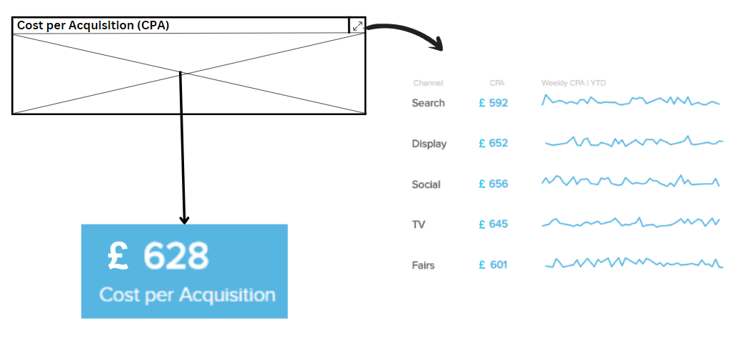

Figure 21. Cost per Acquisition chart example

|  |  |  |
| --- | --- | --- |
| ****Formula**** | ****Range**** | ****Data Source**** |
| Total cost/ Number of new customers | Minimum (0) - Maximum (any) - In Pounds | Revenue  Web services database |

**Engagement Rate:**

The *Engagement rate* metric is the key success factor for social media campaigns. It shows customer engagement with several social media applications, and the CMO knows whether the marketing is working well. For example, in the Customer engagement rate, the customer comments were the most important and valuable data than other likes or reactions.

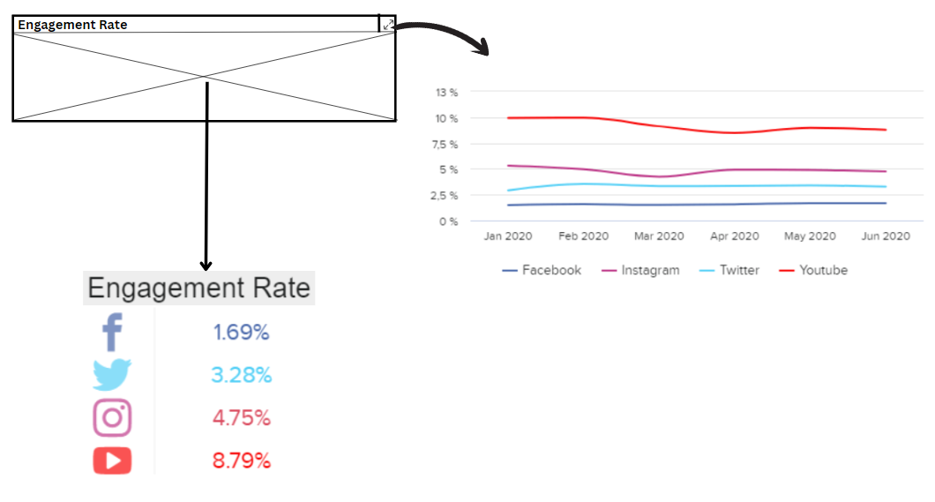

Figure 22. Engagement Rate chart example

|  |  |  |
| --- | --- | --- |
| ****Formula**** | ****Range**** | ****Data Sources**** |
| Number of reactions / Number of impressions or views | (0 - 100) % | Social media activity data  Web services data |

**Cost Per Click (CPC):**

The *Cost Per Click* metric will show how much the British gas organisations pay for a fixed click price each time when someone clicks on a British gas advertisement on the web. The CMO's goal is to decrease the CPC steadily over time, lowering acquisition costs.

Figure 23. Costs Per Click chart example

|  |  |  |
| --- | --- | --- |
| ****Formula**** | ****Range**** | ****Data Source**** |
| The total cost of clicks / Total number of clicks | Minimum (0) - Maximum (any) - In pounds | Web services database |

**Click-through rate (CTR):**

The *Click-through rate* metric helps to measure the success of many different online marketing like Google Adwords, Facebook and Instagram or Organic rankings in Google. In addition, it allows CMO to identify which marketing platform is famous and which needs to be improved.

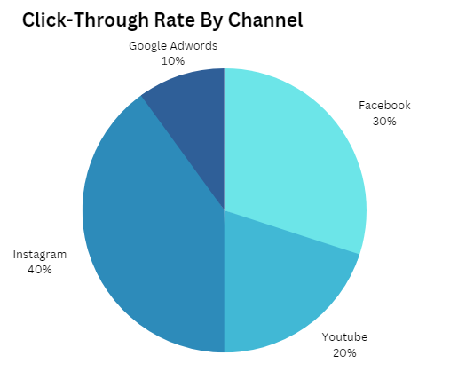

Figure 24. Click-Through Rate chart example

|  |  |  |
| --- | --- | --- |
| ****Formula**** | ****Range**** | ****Data Sources**** |
| (Clicks / Impressions) * 100  **High CTR:** The listing of Advertisements is helpful and relevant.  **Low CTR:** Advertisements listing needs to be more helpful and relevant. | (0 - 100) % | Web services database |

**Bounce Rate:**

The *Bounce rate metric* will show the percentage of visitors who leave the site from the British gas home webpage without viewing another page. The goal for CMO is to decrease the bounce rate by deploying an effective marketing strategy to increase the session time of customers.

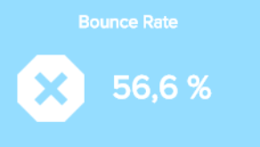

Figure 25. Bounce Rate chart example

|  |  |  |
| --- | --- | --- |
| ****Formula**** | ****Range**** | ****Data Source**** |
| (Total number of one-page visits / Total number of entries to the website) * 100 | (0 - 100) % | Website Activity Data |

|  |
| --- |
| OVERALL ANALYSIS DIMENSIONS |
|  |

Descriptive Analysis:

* Current Customer satisfaction level
* Detecting Customer Loyalty
* Revenue summary statistic

Diagnostic Analysis:

* Retention analysis

Predictive Analysis:

* Revenue based on customer loyalty

Prescriptive Analysis:

* Customer acquisition based on Engagement rate

|  |
| --- |
| CONCLUSION |
|  |

This project represents detailed specifications of dashboards which will be helpful for the CEO, CMO and CSD. It will help regain customers, improve the business, and take wise decisions with the help of these executive dashboards. "In today’s competitive market situation, it is extremely important for small business and large corporations to have permanent access to analytical reports regarding their business activities. Such access may be granted by modern data analytics and visualization techniques" (Orlovskyi, D. and Kopp, A. (2020)) . Such techniques and efficient KPI metrics were defined in the dashboard and perfectly designed for the betterment of the British gas corporation.

If the investment is granted for this project, the future scope of this project will be enormous, and soon British gas organization will see a positive change. Raise in Financial position and Increased Customer trust will eventually happen.

|  |
| --- |
| REFERENCES |
|  |

Richard Simmonds (2021) *British Gas loses 2% of customers and profits hit record low due to pandemic and increased competition*, *Dyball Associates*. Available at: <https://www.dyballassociates.co.uk/british-gas-loses-2-of-customers-and-profits-hit-record-low-due-to-pandemic-and-increased-competition> (Accessed: January 5, 2023).

Centrica (2023) *Our strategy | Centrica plc*. Available at: <https://www.centrica.com/who-we-are/our-strategy/> (Accessed: January 5, 2023).

Few, S. (2006) “Dashboards for strategic purposes,” in *Information dashboard design: The Effective Visual Communication of Data*. Beijing: O'Reilly, pp. 31 (Accessed: January 9, 2023).

Orlovskyi, D. and Kopp, A. (2020) *Ceur-ws.org - CEUR workshop proceedings (Free, open-access publishing ...*, *Ceur-ws.org*. Available at: <https://ceur-ws.org/Vol-2833/Paper_5.pdf> (Accessed: January 12, 2023).

**Additional Readings:**

Ltd, B.A.E.P. (2022) Business analysis methodology: What is this and is it real?, Business Analysis Excellence. Available at: [https://business-analysis-excellence.com/business-analysis-methodology/#:~:text=Although%20there%20is%20no%20single,within%20your%20project%20or%20organisation](https://business-analysis-excellence.com/business-analysis-methodology/%23:~:text=Although%20there%20is%20no%20single,within%20your%20project%20or%20organisation). (Accessed: January 9, 2023).

Chakraborty, A. (2021) Role of an business analyst in an agile environment, Analytics Vidhya. Available at: [https://www.analyticsvidhya.com/blog/2021/10/role-of-an-business-analyst-in-an-agile-environment/#:~:text=What%20is%20Agile%20Methodology%3F,team%20members%20and%20project%20stakeholders](https://www.analyticsvidhya.com/blog/2021/10/role-of-an-business-analyst-in-an-agile-environment/%23:~:text=What%20is%20Agile%20Methodology%3F,team%20members%20and%20project%20stakeholders). (Accessed: January 9, 2023).

Smith, S. (2021) 13 executive dashboard examples organized by department, ClearPoint Strategy. Available at: [https://www.clearpointstrategy.com/executive-dashboard-examples/](https://www.clearpointstrategy.com/executive-dashboard-examples/%20) (Accessed: January 10, 2023).

Baker, K. (2021) Customer dashboards: Which metrics to track and Customer Service dashboard examples, HubSpot Blog. HubSpot. Available at: [https://blog.hubspot.com/service/customer-dashboard](https://blog.hubspot.com/service/customer-dashboard%20) (Accessed: January 11, 2023).

Retention rate: KPI Example (2022) Geckoboard. Available at: [https://www.geckoboard.com/best-practice/kpi-examples/retention-rate/#:~:text=The%20average%2030%2Dday%20rate,higher%20depending%20on%20your%20industry](https://www.geckoboard.com/best-practice/kpi-examples/retention-rate/%23:~:text=The%20average%2030%2Dday%20rate,higher%20depending%20on%20your%20industry). (Accessed: January 11, 2023).

Top 16 marketing KPI examples (2022) Top 16 Marketing KPIs – See Crucial Marketing KPI Examples. Available at: <https://www.datapine.co.uk/kpi-examples-and-templates/marketing> (Accessed: January 12, 2023).